

# **WIRELESS SPEED AND DIRECTION CONTROL OF DC MOTOR**

A MINI PROJECT

REPORT

*Submitted by*

**NAME OF THE STUDENTS**

KIRAN K V – 1NH19EE400

LIKITHA– 1NH19EE401

SUSHMITHA T S – 1NH19EE404

*In partial fulfilment for the award of the degree of*

BACHELOR OF ENGINEERING

IN ELECTRICAL AND ELECTRONICS ENGINEERING



**Bonafide Certificate**

This is to Bonafide that the mini project report entitled “**WIRELESS DIRECTION CONTROL OF DC MOTOR**” submitted by **Kiran K V(1NH19EE400), Likitha(1NH19EE401), Sushmitha T S(1NH19EE404)**, Department of Electrical Engineering, New Horizon College of Engineering, Bangalore in partial fulfilment for the award of the degreeof Bachelor of Engineering , is a record of bonafide work carried out by him/her under my supervision, as per the NHCE code of academic and research ethics.

The contents of this report have not been submitted and will not be submitted either in part or in full, for the award of any other degree or diploma in this institute or any other institute or university. The project report fulfils the requirements and regulations of the institution and in my opinion meets the necessary standards for submission.

|  |  |
| --- | --- |
| Dr.Deepa B  Guide | Dr. S. Ramkumar  HoD |



**Acknowledgement**

With immense pleasure and a deep sense of gratitude, I wish to express my sincere thanks to my supervisor **Dr. Deepa B**, Professor, Department of Electrical Engineering, New Horizon College of Engineering, without her/his motivation and continuous encouragement, this mini-project would not have been successfully completed.

I am grateful to the Chairman of New Horizon Educational Institution, **Dr. Mohan Manghnani** for motivating me to carry out research in the NHCE and for providing me with infrastructural facilities and many other resources needed for my project work.

I express my sincere thanks to **Dr. S. Ramkumar** HoD, Department of Electrical Engineering, New Horizon College of Engineering for his kind words of support and encouragement.

I wish to extend my profound sense of gratitude to my parents for all the sacrifices they made during my project and providing me with moral support and encouragement whenever required.

Date:04/05/2020

Place: Bangalore

Kiran K V

Likitha

Sushmitha T S

**Abstract**

DC motors are used in various applications due to its speed, cost, low maintenance etc. It will be advantageous to develop a system, which uses RF communication to control the speed of dc motor without any wire communication .Which executes with respect to signal sent by the RF transmitter. There are several application with dc motors in our daily life obviously there exists many applications where there might be a need to control the speed of dc motors. There exists many ways of controlling the speed of DC motor. Of the available ones, PWM technique is the most efficient one for controlling speed as we energy saving.

**INDEX**

1. Introduction
2. Components
3. Components Description
4. Circuit diagram
5. Working of project
6. Conclusion
7. Reffrence
8. **INTRUDYION**

DC engines are utilized in different applications in businesses. It is constantly favorable to control the heading of engine in least difficult way. This paper speaks to controlling system of heading of an engine by utilizing remote. In a different remote RF modules are utilized in which STT-434 MHz is Transmitter, STR434 MHz is Receiver, HT12E RF is Encoder and HT12D is RF Decoder. Four switches are given at the transmitter end, to control the heading of the dc engine which is likewise associated at the beneficiary side. Two push-toon switches are given to turn the engine in Clock savvy/Counter clock insightful heading. Driven sign is additionally accommodated visual sign.

1. **COMPONENTS**

* RF-Transmitter
* RF-Reciver
* HT12E(Encider)
* HT12D(Decoder)
* L293D-Motor driver IC
* 12v Battary
* 7404 IC
* DC Motor
* Bread board

1. **COMPONENTS DESCRIPTION**

**RF-Transmitter and Reciver**

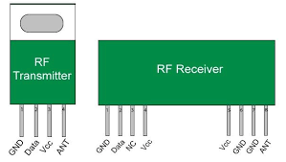

Fig 1. rf transciver

1. **Transmitter**

The term RF signifies "Radio Frequency". A RF handset module will reliably work in a couple that is it needs a Transmitter and Receiver to send and Send data. A transmitter can simply send information and a Receiver and can simply get it, so data can by and large be sent beginning with one end then onto the following and not the opposite path around.

The Transmitter module comprises of three pins in particular Vcc, Din and ground as appeared previously. The Vcc pin has a wide range input voltage from 3V to 12V. The transmitter expends a base current of 9mA and can go as high as 40mA during transmission. The middle pin is the information pin to with the sign to be transmitted is sent. This sign is then adjusted utilizing the ASK (Amplitude Shift Keying) and afterward sent on air at a recurrence of 433MHz. The speed at which it can transmit information is around 10Kbps.

1. **Reciver**

The Receiver module has four pins in particular Vcc, Dout, Linear out and Ground as appeared previously. The Vcc pin ought to be fueled with a managed 5V gracefully. The working current of this module is under 5.5mA. The pins Dout and Linear out is shorted together to get the 433Mhz sign from air. This sign is then demodulated to get the information and is conveyed through the information pin.

1. **HT12E(Encoder)**

The essential capacity of HT12E is to encode a 12-piece and send it out through the yield pin. Since the IC accompanies an in-manufactured Oscillator it is anything but difficult to make this IC work. The IC is has a wide scope of working voltage from 2.4V to 12V, however regularly the Vcc (pin 18) is fueled by +5V and the ground (pin 9) is grounded. Pull the Transmission Enable (pin 14) to ground to actuate transmission. For disentangling an information the IC will requires an oscillator, fortunately this IC has one in-manufactured. We simply need to associate the OSC1 and OSC2 (pin 15 and 16) through a 1M resistor to conjure it. The 4-piece information that must be sent must be given to the pins AD0 to AD1 and a location of 8-piece must be set utilizing the pins A0 to A7. It is significant that your Decoder ought to likewise have this equivalent location for them to converse with one another. A fundamental association graph for the HT12E IC is demonstrated as follows

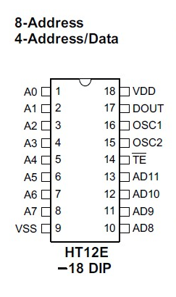

Fig 2. ht12e(encoder)

1. **HT12D(Decoder)**

The essential capacity of HT12D is to disentangle the 12-piece that is gotten by the information pin. Since the IC accompanies an in-fabricated Oscillator it is exceptionally simple to make this IC work. The IC is ought to be controlled by 5V (pin 18) and the ground (pin 9) is grounded. For translating an information the IC will requires an oscilator, fortunately this IC has one in-assembled. We simply need to associate the OSC1 and OSC2 (pin 15 and 16) through a 470K resistor to conjure it. The 4-piece information that is gotten can be acquired on pins AD0 to AD1 and a location of 8-piece must be set utilizing the pins A0 to A7. It is significant that your Decoder ought to have a similar location of that of the encoder. An essential circuit chart for the HT12D IC is demonstrated as follows

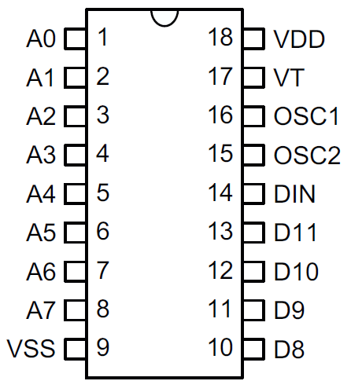

Fig 3. ht12d(decoder)

1. **L293-Motor driver**

**Utilizing this L293D engine driver IC is straightforward. The IC deals with the standard of Half H-Bridge, let us not dive excessively deep into what H-Bridge implies, however until further notice simply realize that H connect is a set up which is utilized to run engines both in clock savvy and hostile to clockwise bearing. As said before this IC is fit for running two engines at the any bearing simultaneously, the circuit to accomplish the equivalent is demonstrated as follows.**

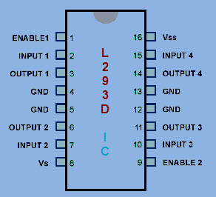

Fig 4. l293d motor driver

1. **DC Motor**

A DC engine is any of a class of revolving electrical engines that changes over direct flow electrical vitality into mechanical vitality. The most widely recognized sorts depend on the powers created by attractive fields. Almost a wide range of DC engines have some interior system, either electromechanical or electronic, to intermittently alter the course of current in part of the engine.

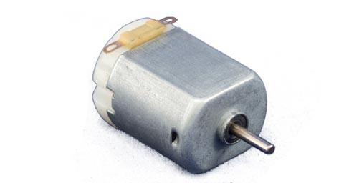

Fig 5. dc motor

1. **7404 IC**

7404 is a NOT entryway IC. It comprises of six inverters which perform intelligent transform activity. The yield of an inverter is the supplement of its info rationale state, i.e., when information is high its yield is low and the other way around.

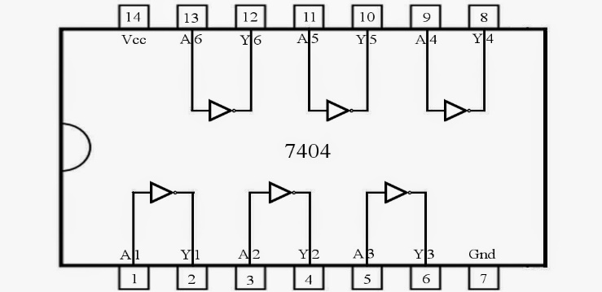

Fig 6. 7404 ic

1. **Bread board**

7404 is a NOT door IC. It comprises of six inverters which perform coherent upset activity. The yield of an inverter is the supplement of its information rationale state, i.e., when info is high its yield is low and the other way around.

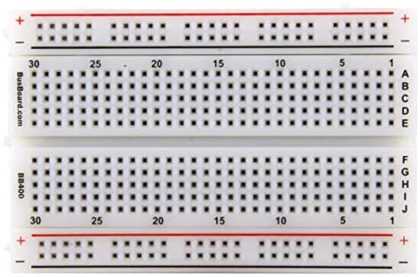

Fig 7. bread board

1. **CIRCUIT DIAGRAMS**

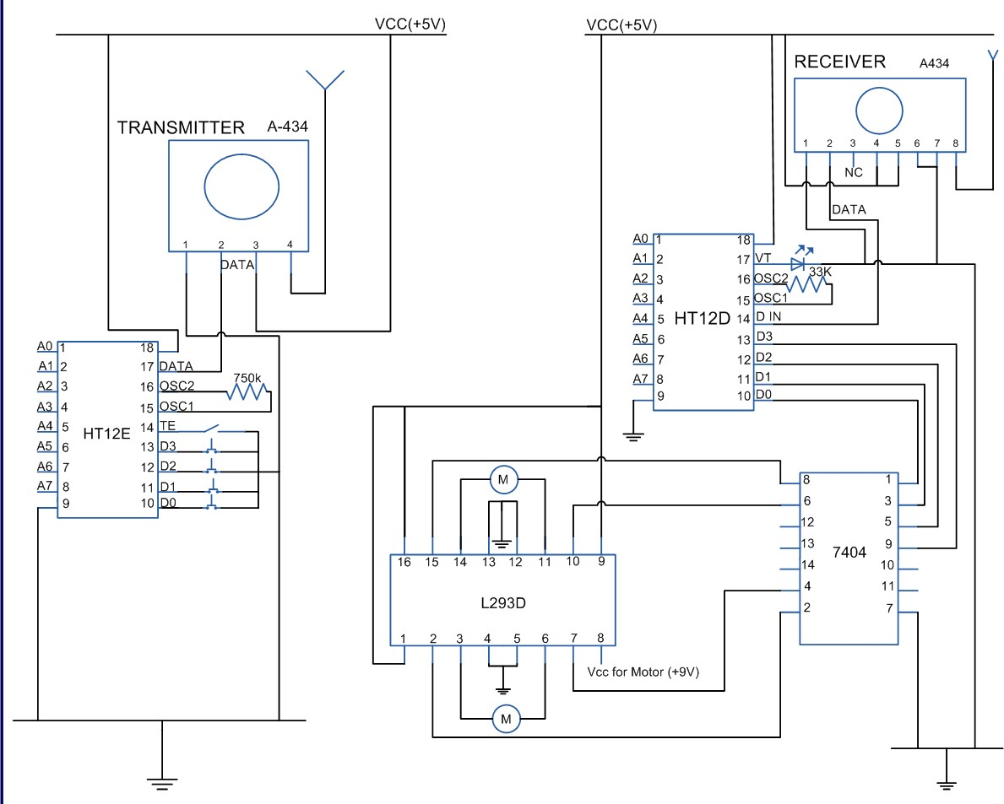

Fig 8. circuit diagram

1. **RF-Transmitter circuit**
2. **Power flexibly:-** This venture utilizes directed 5V, 500 mA and 12V, 500mA force gracefully. 7805 and 7812 three terminal voltage controllers are utilized for voltage guideline.
3. **RF Encoder:-** The four switches are interfaced to the RF transmitter through RF Encoder. The encoder consistently peruses the status of switches; HT12E changes over the equal contributions to sequential yield. It encodes the 12 piece equal information into sequential for transmission through a RF transmitter.
4. **RF Transmitter:-** Transmitter, accepting sequential information from encoder IC (HT12E), transmits it remotely to the RF beneficiary.
5. **Wireless information transmission:-** Electrical correspondence transmitter and beneficiary methods endeavor toward acquiring dependable correspondence easily, with most extreme use of the channel assets. The data transmitted by the transmitter is gotten by the goal by means of a physical medium called a recipient. This physical medium, which is remote, presents contortion, commotion and impedance in the transmitted data bearing sign. To balance these impacts is one of the prerequisites while structuring a transmitter and collector end procedure. Different necessities are force and data transmission productivity at a low execution intricacy.
6. **Switches:-** Four On/Off switches are accommodated controlling rate just as heading.

**2. RF-Reciver circuit**

**(a) RF collector**:- The RF beneficiary gets sequential information, and demodulates the transmitted information sign, and offers it to RF decoder.

**(b) the RF decoder:-** RF decoder changes over the sequential contribution to resemble yields. It interprets sequential locations and information got by, state, a RF collector, into equal information and sends them to yield information pins.

**(c) L293-Motor driver:-** The L293D is intended to give bidirectional drive flows of up to 600-mA at voltages from 4.5V to 36V. At the point when an empower input is high, the related drivers are empowered, and their yields are dynamic and in stage with their information sources. At the point when the empower input is low, those drivers are debilitated, and their yields are off and in the highimpedance state.

**(d) DC engine:-** DC engines are constantly favored in view of its speed, weight, size, and cost. You can control the speed of engine, course of revolution; additionally do encoding of the pivot made by DC engine interfacing to the determined IC. In the present task the movement of wanderer is constrained by these DC engines of 100RPM and works for 9V of DC voltage.

1. **WORKING OF PROJECT**

This circuit utilizes RF module to control DC engines through an engine driver IC L293D. Transmission is empowered by giving a low piece to pin14 (TE, dynamic low) of encoder HT12E. The controls for engine are first sent to HT12E. Pins 10 and 11 (D0-D1) are utilized to control one engine while pins 12 and 13 (D2-D3) to control another engine. The information signs of encoder HT12E chip away at negative rationale. In this way a specific sign is sent by giving a low piece to the comparing information pin of encoder.

The equal signs created at transmission end are first encoded (into sequential organization) by HT12E and afterward moved through RF transmitter (434 MHz) at a baud pace of around 1-10 kbps. Similar signs are gained by RF recipient after which it is decoded by HT12D. For additional subtleties, allude RF remote control.

Since the encoder/decoder pair utilized here chips away at negative rationale, the decoded signals are taken care of to an inverter (NOT entryway) IC 74LS04. The best possible (rearranged) signals are then provided to L293D. L293D contains two inbuilt H-connect driver circuits to drive two DC engines all the while, both in forward and switch course.

The engine activities of two engines can be constrained by input rationale at pins 2 and 7 and pins 10 and 15. Info rationale 00 or 11 will stop the relating engine. Rationale 01 and 10 will pivot it in clockwise and anticlockwise ways, individually. Subsequently, contingent on the signs produced at the transmission end, the two engines can be pivoted in wanted ways.

1. **CONCLUSION**

The framework is a little, straightforward, financially savvy and useful for remote control of gear. Utilizing the radio recurrence we can on or off gadgets .We can control home machines and different mechanical instrumentation. In the event that we use infrared,then infrared sign can't go through divider. So on the off chance that we need to control our gadget outside the divider can't do it, the main way is that to utilize some RF remote control .The circuit (transmitter and recipient) utilize scarcely any segment and conventional .it's anything but difficult to assemble in light of the fact that we don't need to tune curl or variable capacitor.

1. **REFRENCE**

[https://vijaykamble.wordpress.com/2011/04/03/remote engine control-through-rf/](https://vijaykamble.wordpress.com/2011/04/03/remote%20engine%20control-through-rf/)

[https://www.engineersgarage.com/commitments/remote-controlling-dc-engine utilizing rf-module-section 9-23/](https://www.engineersgarage.com/commitments/remote-controlling-dc-engine%20utilizing%20rf-module-section%209-23/)

<http://ijaerd.com/papers/special_papers/EE009%20%20Wireless%20Control%20of%20Dc%20Motor%20Using%20RF%20Communication.pdf>

<https://circuitdigest.com/electronic-circuits/wireless-dc-motor-control-circuit-diagram>

<https://courses.engr.illinois.edu/ece445/getfile.asp?id=5313>

<https://www.scribd.com/doc/239574302/Wireless-Speed-and-Direction-Control-of-Dc-Motor-Using-Rf-Technology>